Op-amp based Schmitt trigger, astable, and monostable multivibrator circuits
Aim: To understand the operation of Schmitt trigger, astable, and monostable op-amp circuits.
Schmitt trigger:
A Schmitt trigger circuit is a fast-operating voltage-level detector. When the input voltage arrives at the upper or lower trigger levels, the output changes rapidly. The circuit operates with almost any type of input waveform, and it gives a pulse-type output.
The input voltage V_{in} is applied to the inverting input terminal and the feedback voltage goes to the non-inverting terminal. This means the circuit uses positive voltage feedback instead of negative feedback. The output voltage will remain in a given state until the input voltage exceeds the reference voltage for that state. For instance, if the output is positively saturated, the reference voltage is +βVsat. The input voltage V_{in} must be increased slightly above +βVsat to switch the output voltage from positive to negative. Once the output is in the negative state, it will remain there indefinitely until the input voltage becomes more negative than –βVsat. Then, the output switches from negative to positive.
The feedback fraction, β = R2 / (R1 + R2)
When the output is positively saturated, the reference voltage applied to the non-inverting input is
Vref = + βVsat
When the output is negatively saturated, the reference voltage is
Vref = -βVsat
The trip points are defined as the two input voltages where the output changes states. The upper trip point (abbreviated UTP) has a value UTP = +βVsat and the lower trip point has a value LTP = –βVsat
The difference between the trip points is the hysteresis H and is given as
H = + β Vsat – (-β Vsat) = 2 β Vsat
The hysteresis is caused due to positive feedback. If there were no positive feedback, β would equal zero and the hysteresis would disappear, because the trip points would both equal zero. Hysteresis is desirable in a Schmitt trigger because it prevents noise form causing false triggering.
A Schmitt trigger is a comparator with hysteresis (see Fig. 1). When the input voltage is varied from low to high values, the output transition occurs at V_{i} = V_{TH}. When the input voltage is varied from high to low values, the output transition occurs at V_{i} = V_{TL}. Fig. 2 shows an op amp Schmitt trigger circuit. The diode arrangement at the output limits the output voltage to ± 6.3 V.
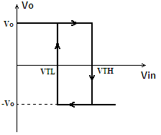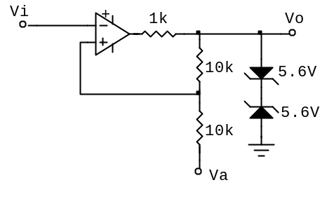
Figure 1: Schmitt trigger hysteresis Figure 2: Schmitt trigger

- Wire the Schmitt trigger circuit shown in Fig. 2. Connect the reference point V_{a} to ground.
- Apply a sine wave with 12V p-p at the input V_{i}.
- Observe the waveforms at the input and output on an oscilloscope versus time as well as in the X-Y mode.
- Compare the input voltage levels V_{TH}, V_{TL} with calculated values.
- Repeat the above steps with V_{a} connected to 3 V.

Astable multivibrator
An astable multivibrator switches between two states with a frequency determined by an RC time constant. This feature may be used to make a square wave generator.
When the circuit is turned ON, depending upon the initial conditions, the op amp’s output saturates to either positive or negative rail. Assuming that the op amp saturates at the positive rail, the capacitor starts charging through the resistor R, and the voltage across the capacitor starts to rise. As soon as the voltage at the op amp’s inverting terminal reaches that at the noninverting terminal (the op amp’s output voltage divided by R₁ and R₂), the output switches over to the opposite rail and the capacitor starts to discharge.
Once the inverting terminal reaches the voltage of the non-inverting terminal, the output again drives to the opposing rail voltage and the cycle begins again. Thus, the astable multivibrator creates a square wave with no inputs.
For the circuit in Fig. 3, the time period of the output waveform is,
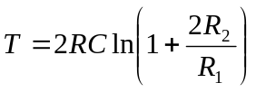
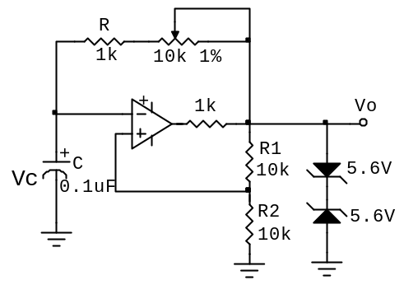
Figure 3: Astable multivibrator

- Wire the astable multivibrator circuit as shown in Fig. 3.
- Observe the output voltage and the voltage across the capacitor.
- Vary the potentiometer and observe its effect on the output frequency.
- Disconnect the zener diodes and observe the output voltage and the capacitor voltage. Does the frequency change? Why?

Monostable multivibrator
A monostable multivibrator is a class of multivibrator that has one stable state and one temporarily stable state (quasistable state). On application of a trigger pulse, the circuit makes a transition from stable state to quasistable state. The circuit then returns to its stable state on its own. The duration of the quasistable state is determined by the circuit components (R and C).
The circuit diagram of the circuit is shown in Fig 4(a). A rectified differentiator circuit with R₄ - C₂ – D₂ is used to produce a negative-going narrow pulse which then serves as a trigger to the monostable circuit.

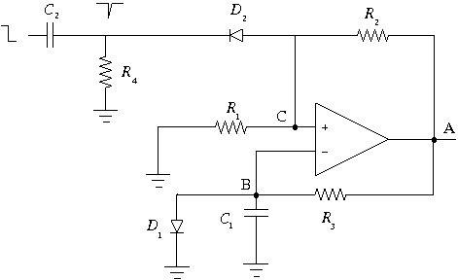
Figure 4 (a)
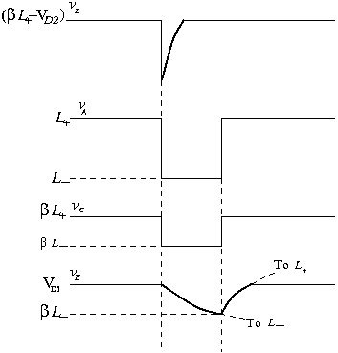
Figure 4 (b)
In the stable state, i.e., when the trigger input has not yet gone low, V_{o} is high (=). R₄ is chosen to be much larger than R₂ and therefore the current through D₂ is small. In other words, V_{C} is given approximately by simple voltage division, V_{C} = , i.e., V_{C}= . Node B is clamped at about 0.7 V. For the op-amp in the stable state V₊= V_{C} = , V₋= V_{B} = 0.7 V. is chosen so that V₊ > V₋ and the op-amp output is at L⁺, consistent with our analysis.
When the input voltage goes low, a negative-going pulse is produced at node C. If this voltage goes below V_{D1} ≈ 0.7 V, the op-amp output changes from L⁺ to L⁻. The diode D₂ is now off and the differentiator circuit is therefore not in the picture. The simplified circuit in this phase is shown in Fig. 5.
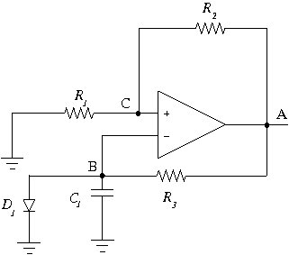
Figure 5
The capacitor now starts discharging towards through R₃. V_{C} is at . When V_{B} becomes less negative than V_{c}, the op-amp output changes back to L⁺ since (V₊ - V₋) = V_{C} - V_{B} is now positive. Beyond this point, C₁ starts charging towards through R₃ and V_{B} gets clamped at 0.7 V when D₁ turns ON. The phase of the output for a time interval that depends on = R₃C₁. Let the capacitor voltage be V_{C1} (t) = A+B.
Let the discharging start at t=0 (see Fig. 4(b)). Then, we have V_{C1} (t) = V_{D1} at t=0, and V_{C1} (∞) =, giving B= and A= V_{D1} - .
V_{C1} (t) is therefore given by,
V_{C1} (t) = (V_{D1} - ) + .
The pulse starts for T seconds, and at t = T, V_{C1} (t) = .
β= (β - ) + ,
T= , τ = R₃C₁.
Lab session
- Design the monostable multivibrator circuit for 3 ms pulse width.
- Wire the circuit (see Fig. 4(a)) with the values calculated from step (1). Verify the monostable pulse width at the output with the period specified in step (1) by applying the negative going pulse input from the signal generator.

